*********************************BOOTSTRAP***********************************

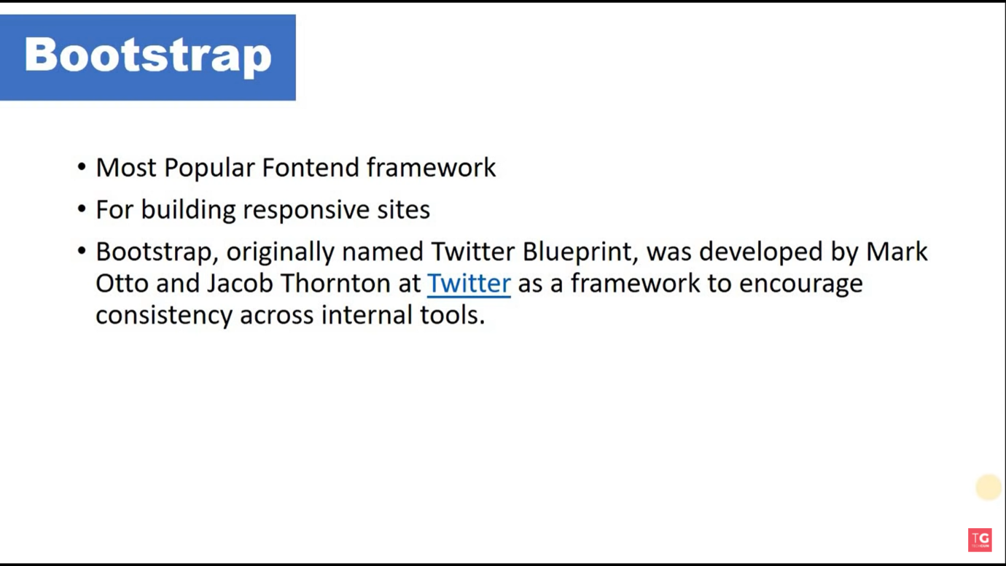

* Way to add bootstrap in our site

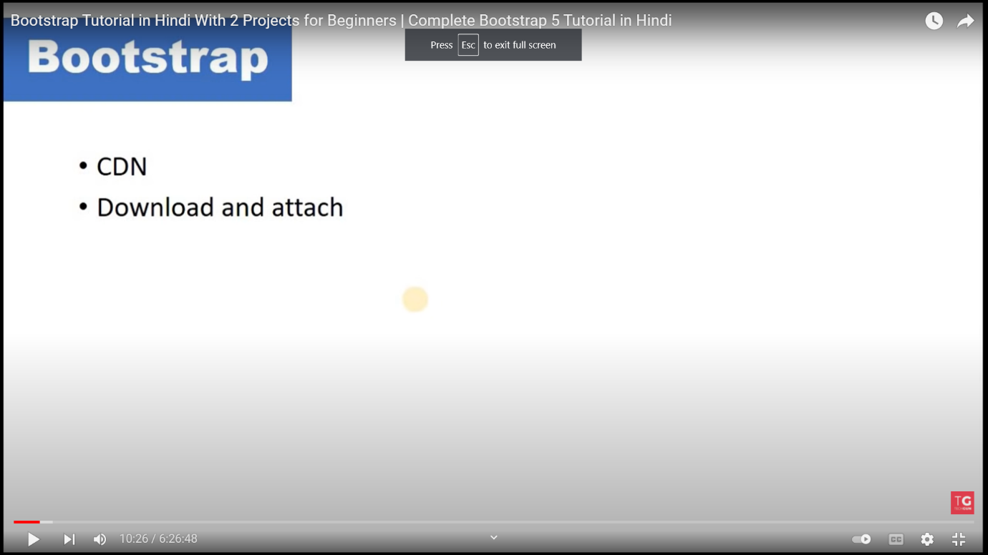

Css :

<!-- CSS only -->

<link href="https://cdn.jsdelivr.net/npm/bootstrap@5.1.3/dist/css/bootstrap.min.css" rel="stylesheet" integrity="sha384-1BmE4kWBq78iYhFldvKuhfTAU6auU8tT94WrHftjDbrCEXSU1oBoqyl2QvZ6jIW3" crossorigin="anonymous">

Java script : import this in the body of html

<!-- JavaScript Bundle with Popper -->

<script src="https://cdn.jsdelivr.net/npm/bootstrap@5.1.3/dist/js/bootstrap.bundle.min.js" integrity="sha384-ka7Sk0Gln4gmtz2MlQnikT1wXgYsOg+OMhuP+IlRH9sENBO0LRn5q+8nbTov4+1p" crossorigin="anonymous"></script>

Short cut for background-color and text-color : class=”bg-primary text-white “

BOOTSTRAP MADE UP OF :

Bootstrap : ( grid system + classes + component )

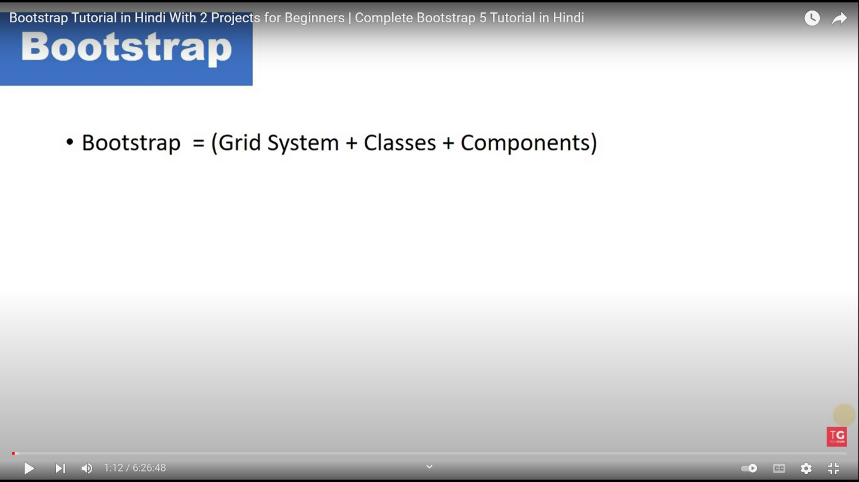

1. GRID SYSTEM:

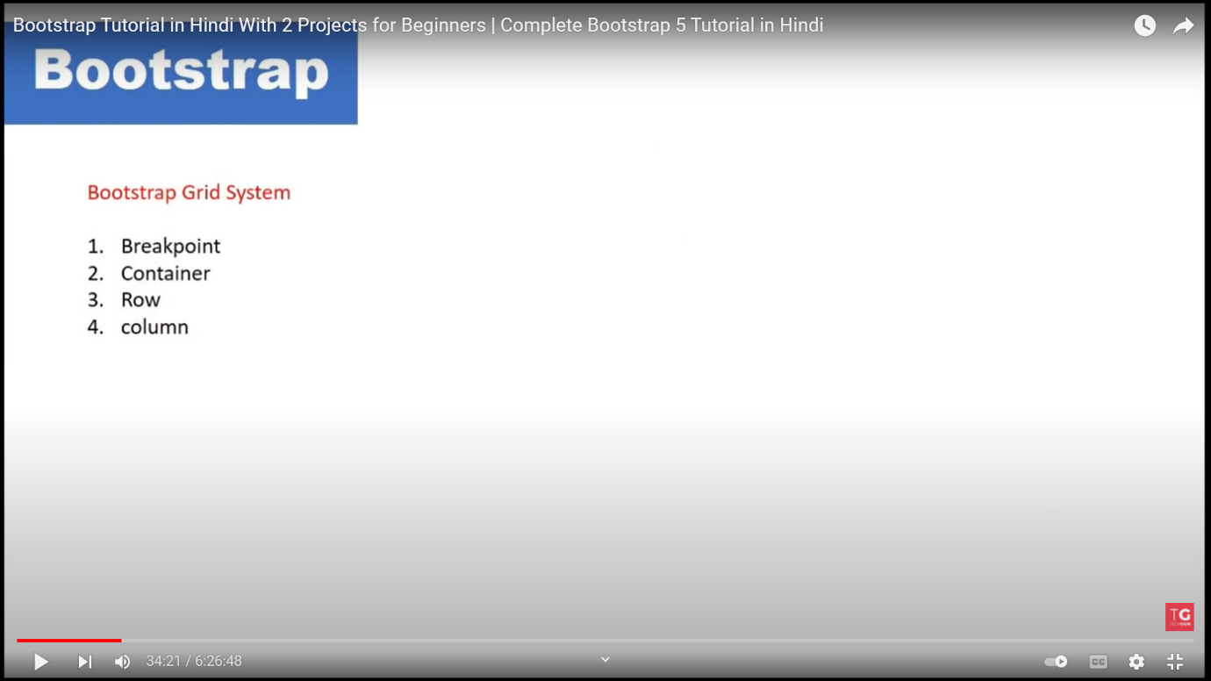

1. BREAKPOINT:

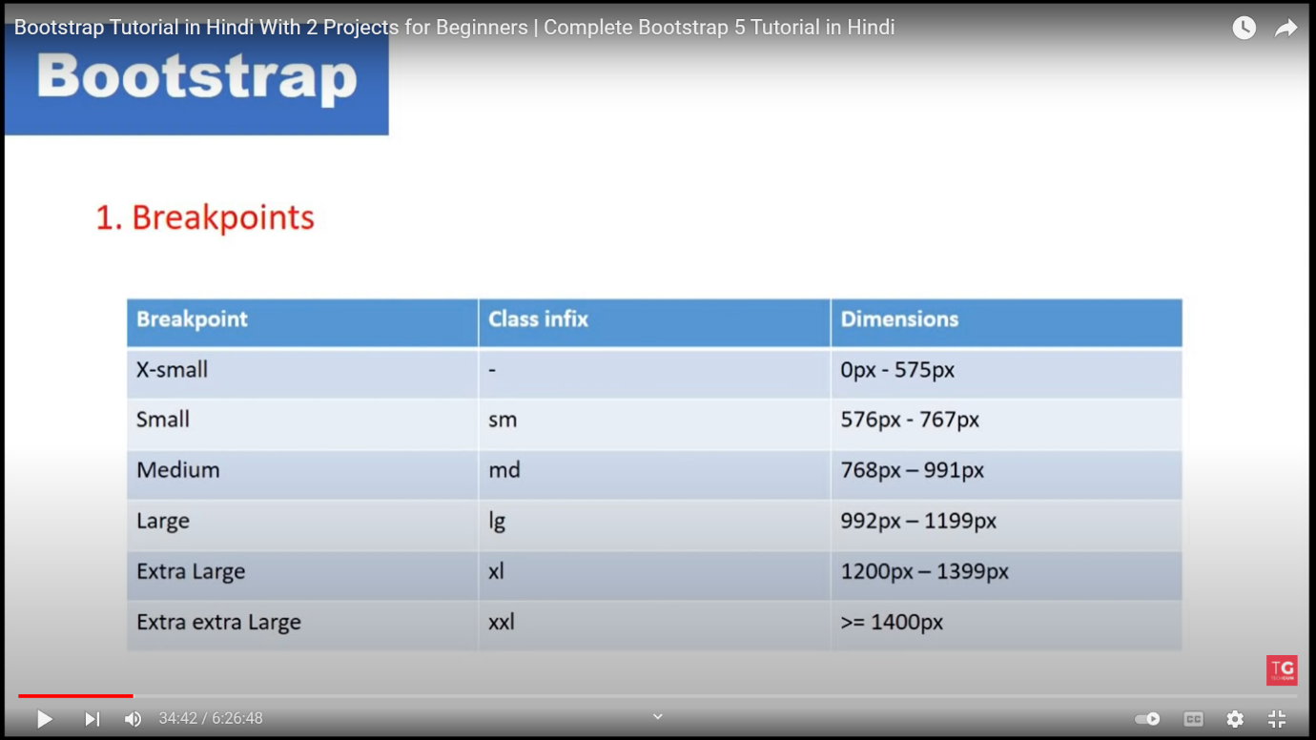

1. Container

Bootstrap comes with three different containers:

* .container, which sets a max-width at each responsive breakpoint

|  | **Extra small** <576px | **Small** ≥576px | **Medium** ≥768px | **Large** ≥992px | **X-Large** ≥1200px |
| --- | --- | --- | --- | --- | --- |
| .container | 100% | 540px | 720px | 960px | 1140px | 1320px |
| .container-sm | 100% | 540px | 720px | 960px | 1140px | 1320px |
| .container-md | 100% | 100% | 720px | 960px | 1140px | 1320px |
| .container-lg | 100% | 100% | 100% | 960px | 1140px | 1320px |
| .container-xl | 100% | 100% | 100% | 100% | 1140px | 1320px |
| .container-xxl | 100% | 100% | 100% | 100% | 100% | 1320px |
| .container-fluid | 100% | 100% | 100% | 100% | 100% | 100% |

* .container-fluid, which is width: 100% at all breakpoints XX-large

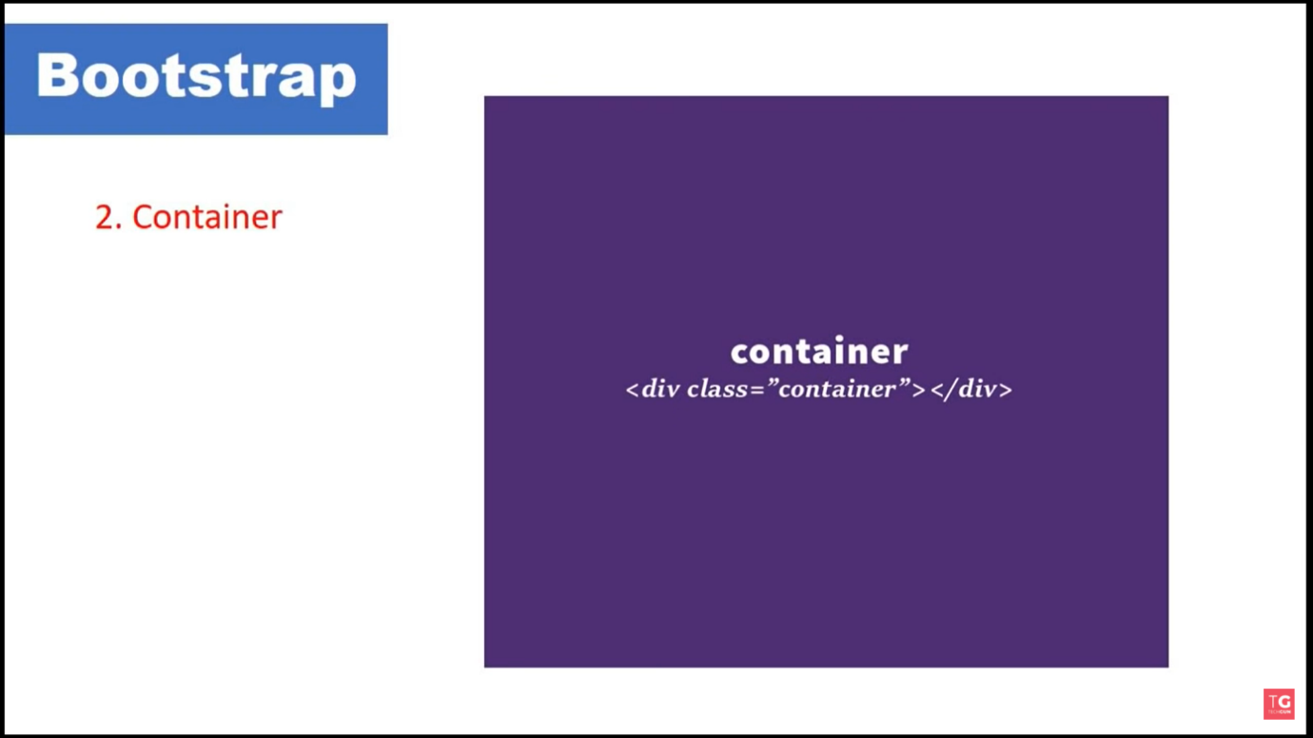

1. . row

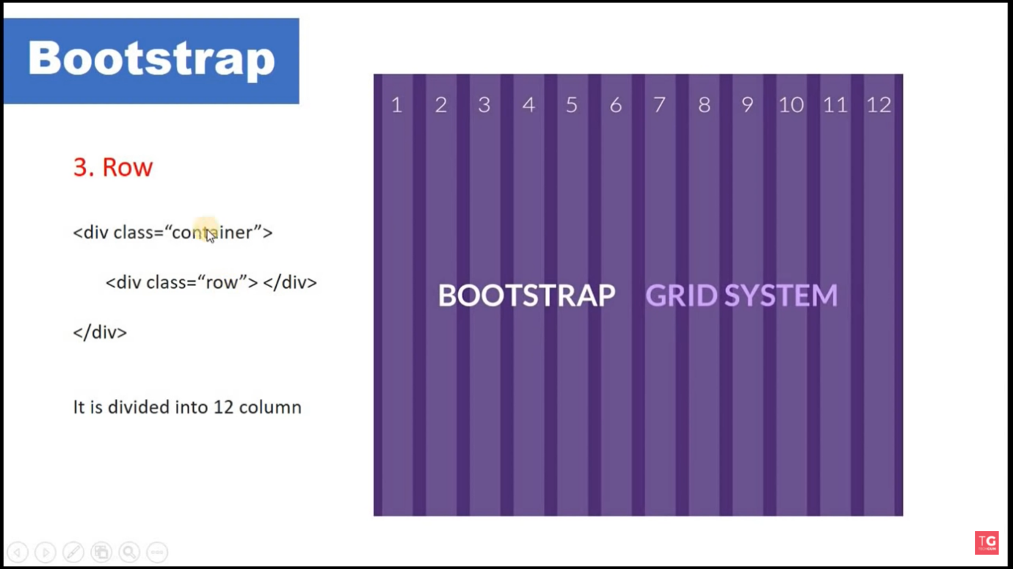

Note : Row can be define under container or column ;

4. COLUMN:

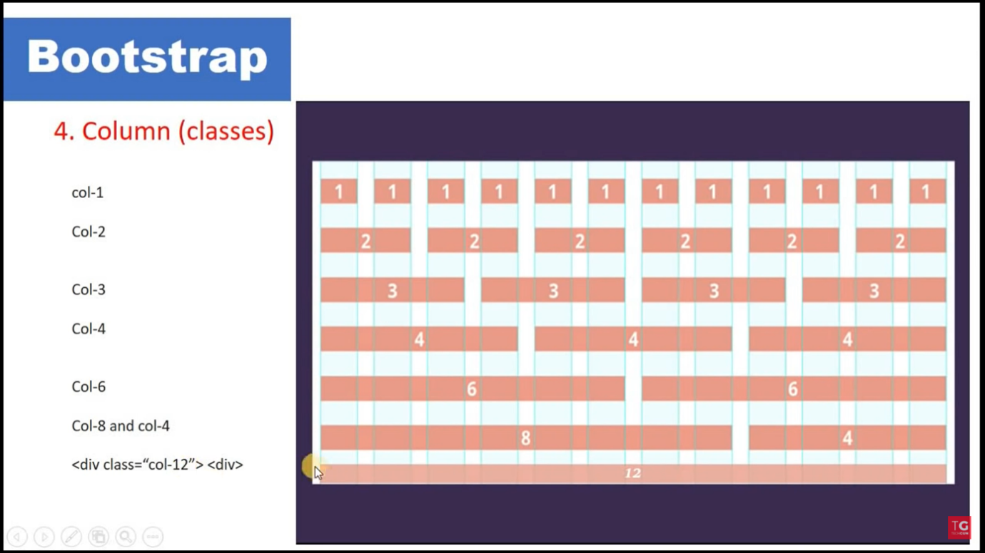

Note : column can only define under row

Remember column can not define under column

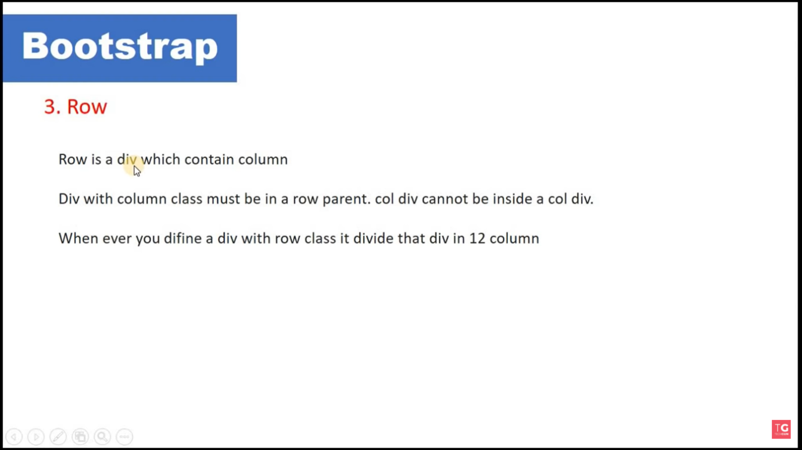

Some concept about row and col :

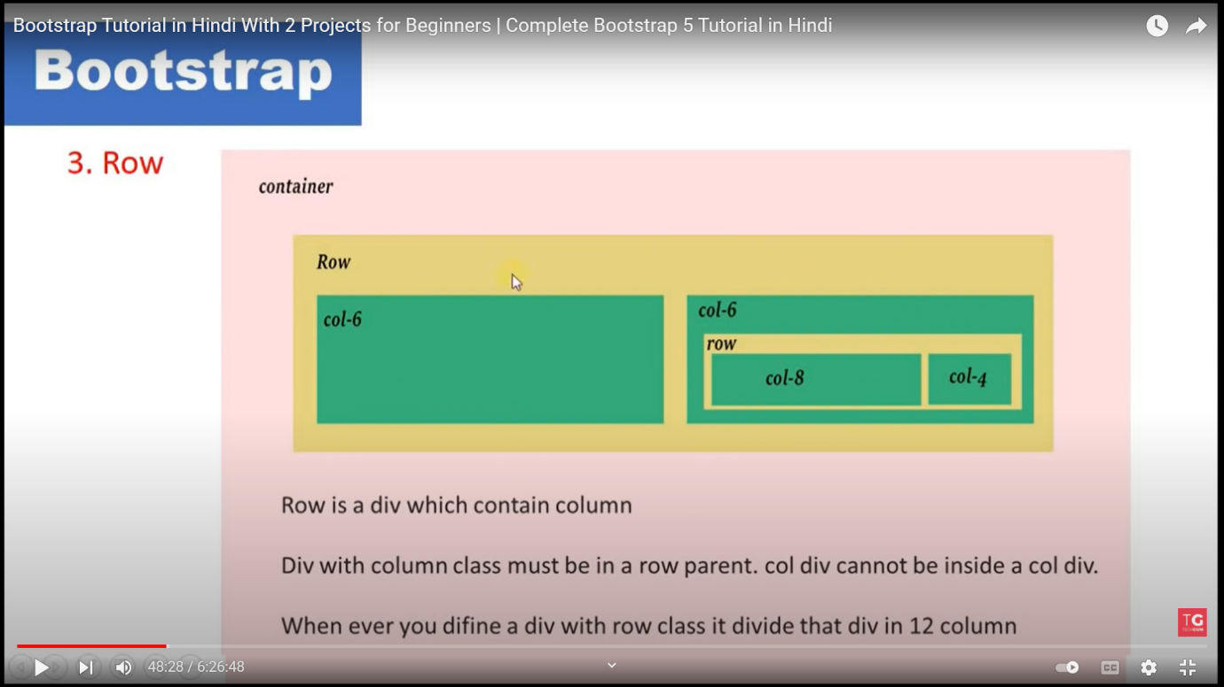

Type of container :

1 . div<class=”container”>

* It will going to give margin width

Eg :

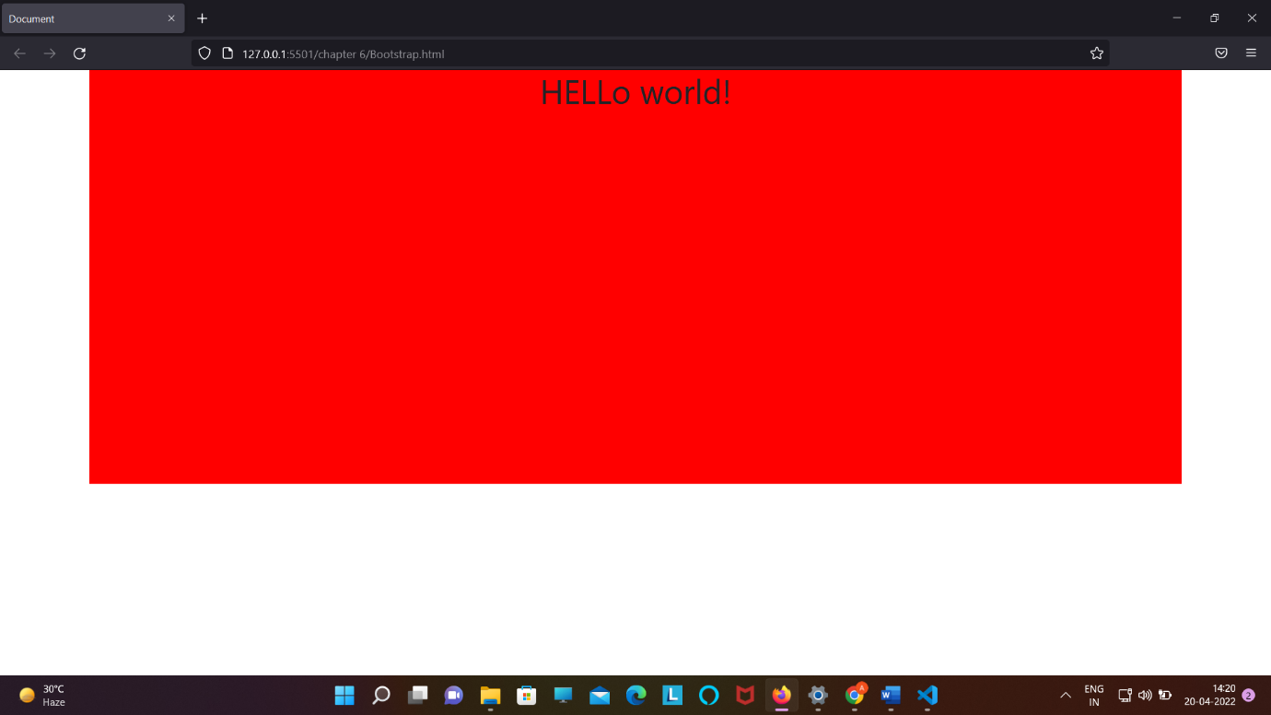

2 . div<class=”container-fluid”>

Note : it will going to 100% width ;

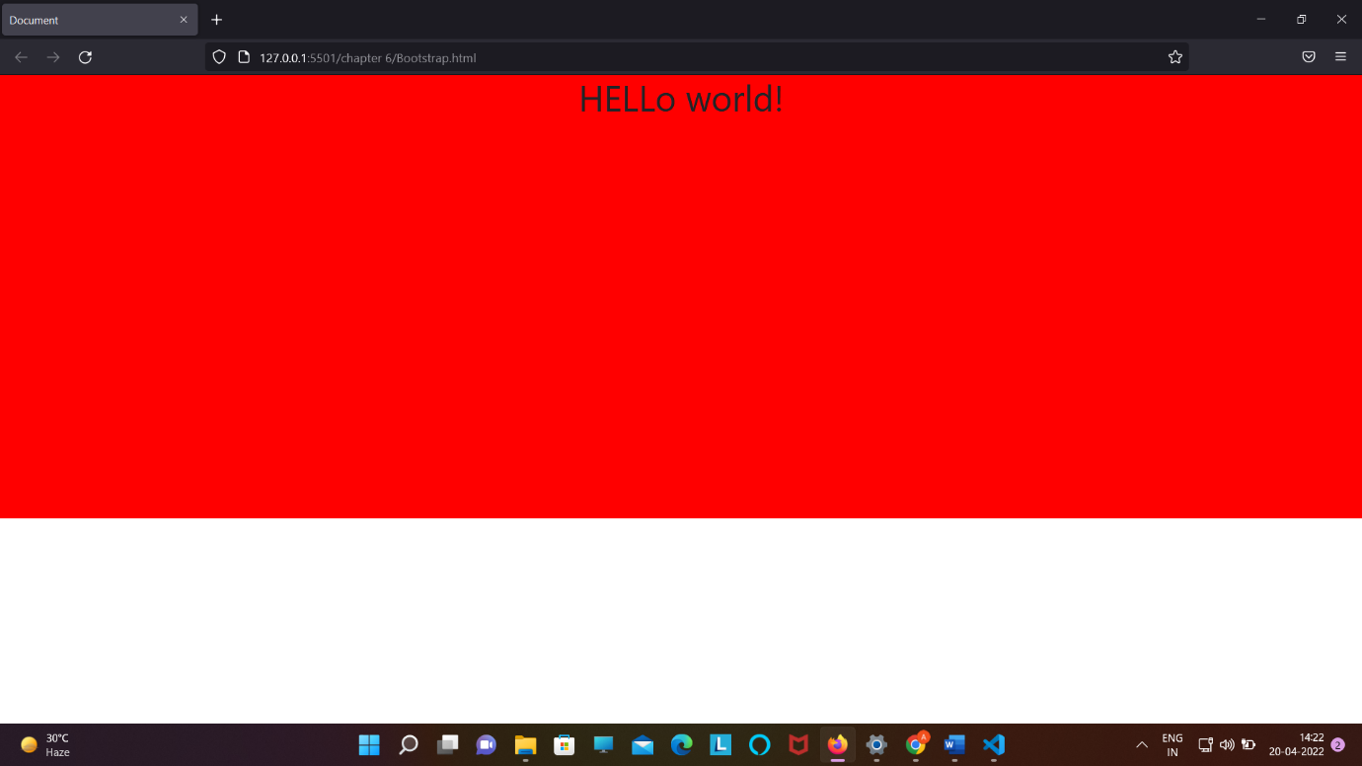

Note : bootstrap flow :

1 .Container -> row -> column -> content

2. In the column

agar hum Kisi div ko Kisi breakpoint ke respect mai define karenge to0 use se jada wale break point ke liye bhi whai rahega but use kam wale ke liye wo full col lega means ( 12 col legea )

Eg :

<div class="container-fluid" id="red">

        <div class="row">

            <div class="col-lg-4 bg-secondary text-white">Col-6</div>

            <div class="col-lg-4 bg-primary text-white">Col-6</div>

            <div class="col-lg-4 bg-success text-white">Col-6</div>

        </div>

    </div>

Writing code for multiple breakpoint :

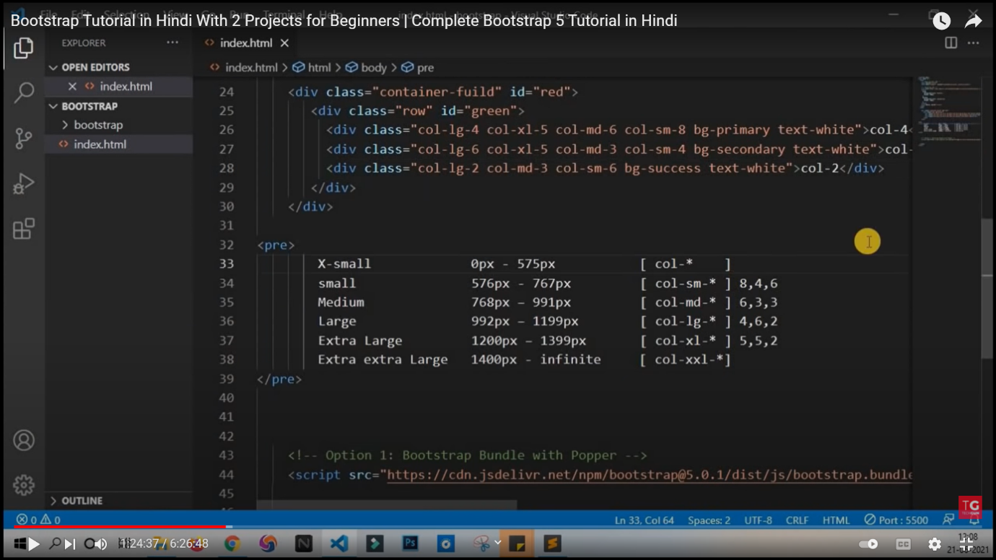

Nested col:

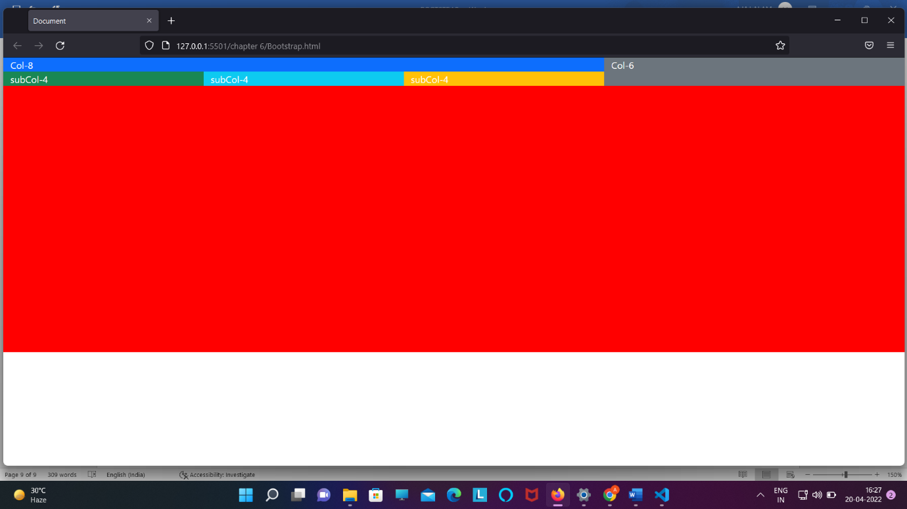

Code :

<!DOCTYPE html>

<html lang="en">

<head>

    <meta charset="UTF-8">

    <meta http-equiv="X-UA-Compatible" content="IE=edge">

    <meta name="viewport" content="width=device-width, initial-scale=1.0">

    <title>Document</title>

    <!-- <link rel="styelsheet" href="bootstrap.css"> -->

    <style>

        #red {

*background-color*: red;

*height*: 500px;

        }

    </style>

    <link href="https://cdn.jsdelivr.net/npm/bootstrap@5.1.3/dist/css/bootstrap.min.css" rel="stylesheet"

        integrity="sha384-1BmE4kWBq78iYhFldvKuhfTAU6auU8tT94WrHftjDbrCEXSU1oBoqyl2QvZ6jIW3" crossorigin="anonymous">

</head>

<body>

    <div class="container-fluid" id="red">

        <div class="row">

            <div class="col-lg-8 bg-primary text-white">Col-8

                <div class="row">

                    <div class="col-lg-4 bg-success">subCol-4</div>

                    <div class="col-lg-4 bg-info">subCol-4</div>

                    <div class="col-lg-4 bg-warning">subCol-4</div>

                </div>

            </div>

            <div class="col-lg-4 bg-secondary text-white">Col-6</div>

        </div>

    </div>

    <script src="https://cdn.jsdelivr.net/npm/bootstrap@5.1.3/dist/js/bootstrap.bundle.min.js"

        integrity="sha384-ka7Sk0Gln4gmtz2MlQnikT1wXgYsOg+OMhuP+IlRH9sENBO0LRn5q+8nbTov4+1p"

        crossorigin="anonymous"></script>

</body>

</html>

Shortcut to divide col :

Method 1 : diving everything equally

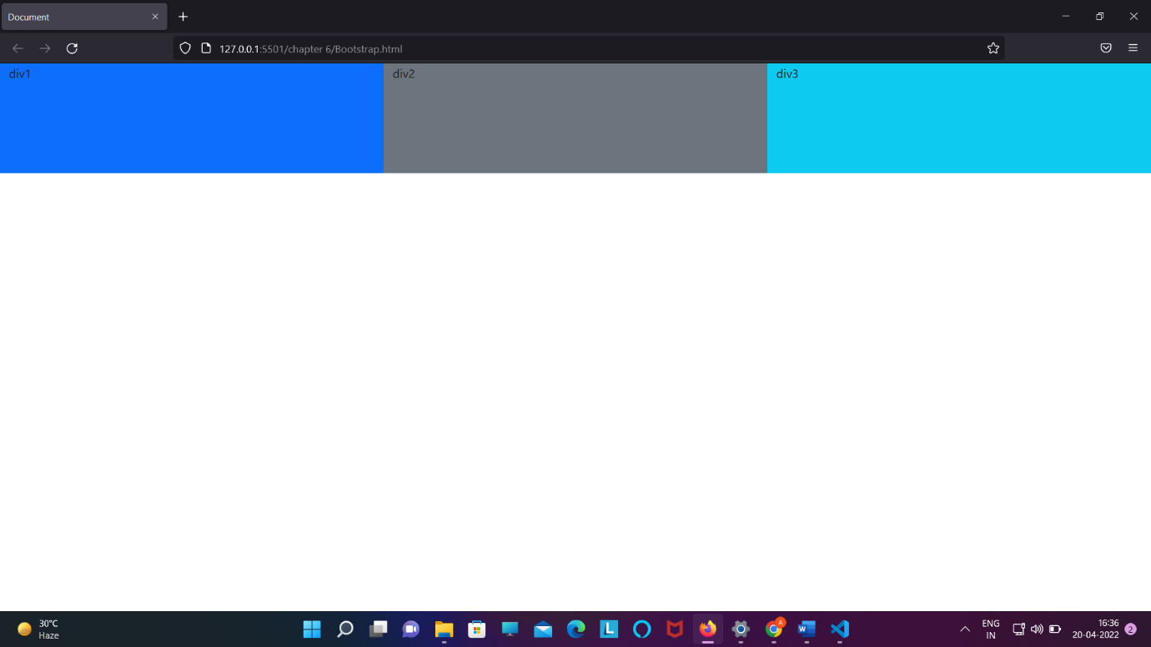

<div class="container-fluid">

        <div class="row">

            <div style="height: 20vh;" class="col bg-primary">div1</div>

            <div style="height: 20vh;" class="col bg-secondary">div2</div>

            <div style="height: 20vh;" class="col bg-info">div3</div>

        </div>

    </div>

2 . diving equally by giving a particular col to any col-length and the remaining into equal part

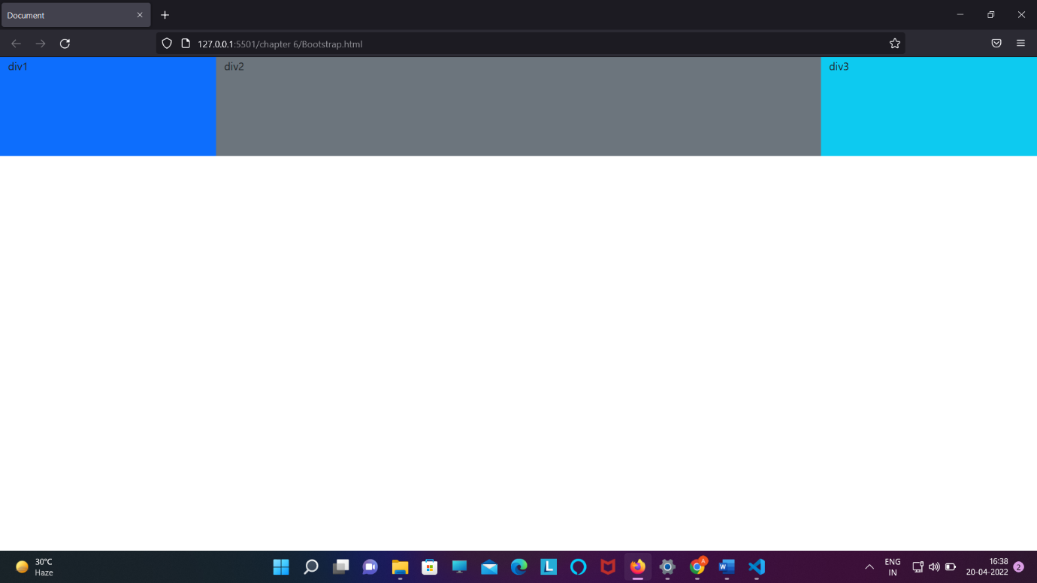

Code :

<div class="container-fluid">

        <div class="row">

            <div style="height: 20vh;" class="col bg-primary">div1</div>

            <div style="height: 20vh;" class="col-7 bg-secondary">div2</div>

            <div style="height: 20vh;" class="col bg-info">div3</div>

        </div>

    </div>

3. jitna text lika ho utan jagha dena ka way

Class=” col-auto”

<div class="container-fluid">

        <div class="row">

            <div style="height: 20vh;" class="col bg-primary">div1</div>

            <div style="height: 20vh;" class="col-auto bg-secondary">Lorem ipsum dolor sit amet consectetur adipisicing elit. Labore, earum?</div>

            <div style="height: 20vh;" class="col bg-info">div3</div>

        </div>

    </div>

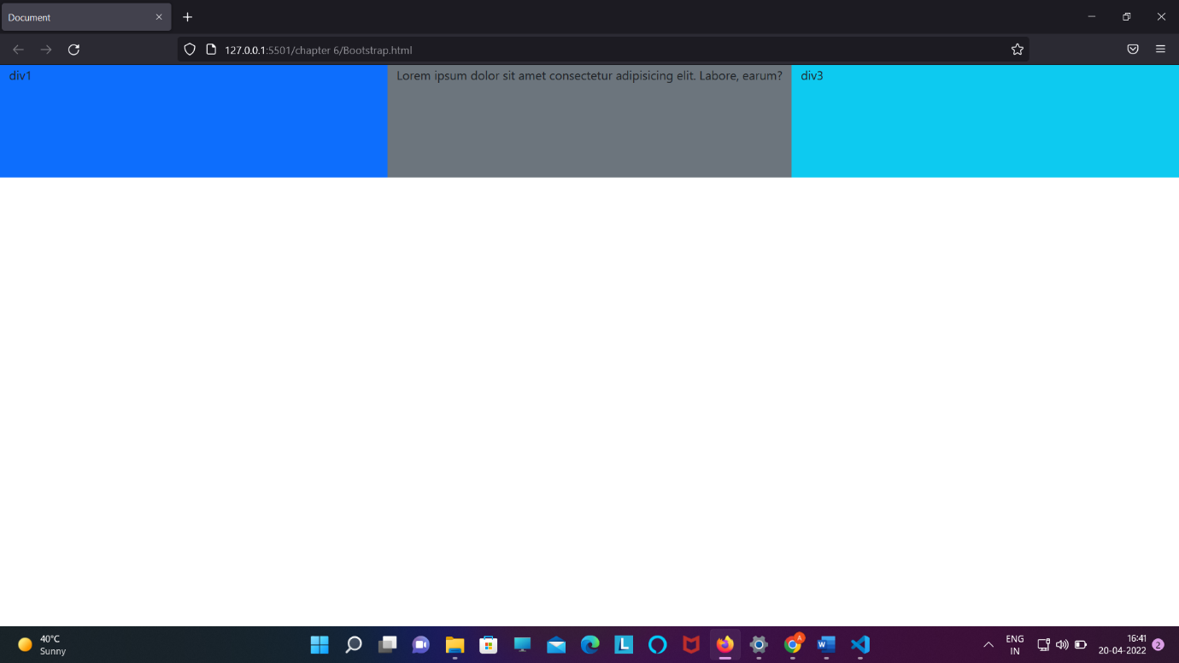

4 . Hum row se bhi define kar sakete hai ki ek line mai kitna coloumn rahega

A . <div class="container-fluid">

        <div class="row row-cols-2">

            <div class="col bg-primary">Div1</div>

            <div class="col bg-secondary">Div2</div>

            <div class="col bg-info">Div3</div>

        </div>

    </div>

Note : by default it will going to divide container into column of 2 for every screen

B. <div class="container-fluid">

        <div class="row row-cols-2">

            <div class="col-md bg-primary">Div1</div>

            <div class="col-md bg-secondary">Div2</div>

            <div class="col-md bg-info">Div3</div>

        </div>

    </div>

Note: it will be going to divide container into 2 columns for every screen smaller than the medium screen.

For screen greater or equal than medium it will be going to do the thing that is written in column class.

1. For screen equal or greater than medium breakpoint which we have given

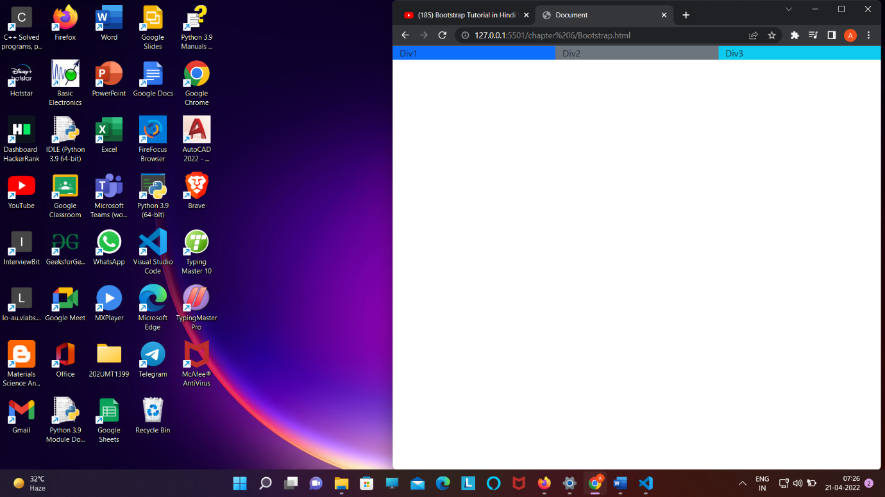

2 . for screen smaller than medium

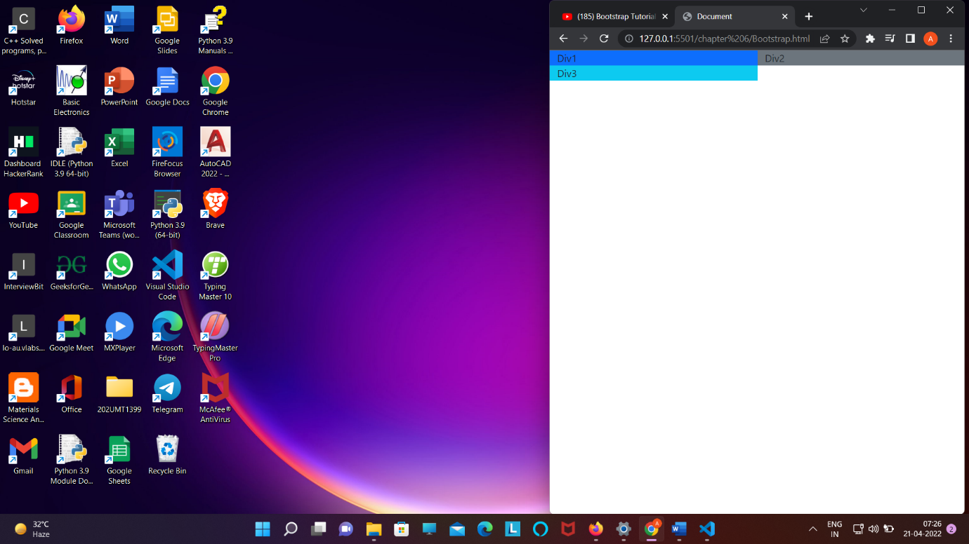

* USING OF FLEX PROPERTY :

1 . align-content

<div class="container-fluid"style="min-height: 40vh;background-color :red">

        <div class="row align-content-center" style="min-height:20vh;border:3px solid greenyellow">

            <div class="col bg-primary">Box 1</div>

            <div class="col bg-secondary">Box 2</div>

            <div class="col bg-info">Box 3</div>

        </div>

    </div>

* 1. align-items-center/start/end

1. <div class="container-fluid"style="min-height: 40vh;background-color :red">
2. <div class="row align-items-center" style="min-height:20vh;border:3px solid greenyellow">
3. <div class="col bg-primary">Box 1</div>
4. <div class="col bg-secondary">Box 2</div>
5. <div class="col bg-info">Box 3</div>
6. </div>
7. </div>

2. justify-content-start/center/end/around/between/envenly

<div class="container-fluid"style="min-height: 40vh;background-color :red">

        <div class="row justify-content-between" style="min-height:20vh;border:3px solid greenyellow">

            <div class="col-4 bg-primary">Box 1</div>

            <div class="col-4 bg-secondary">Box 2</div>

            <!-- <div class="col bg-info">Box 3</div> -->

        </div>

    </div>

1. . align-self-center/end (element property )
2. <div class="container-fluid"style="min-height: 40vh;background-color :red">
3. <div class="row " style="min-height:20vh;border:3px solid greenyellow">
4. <div class="col align-self-end bg-primary">Box 1</div>
5. <div class="col align-self-center bg-secondary">Box 2</div>
6. <div class="col align-self-start bg-info">Box 3</div>
7. </div>
8. </div>

* 4. Reordering for different breakpoint
* <div class="container-fluid">
* <div class="row" style="min-height: 20vh; border: 3px solid greenyellow">
* <div class="col order-lg-3 order-sm-2 bg-primary">Box 1</div>
* <div class="col order-lg-1 order-sm-3 bg-secondary">Box 2</div>
* <div class="col orger-lg-2 order-sm-1 bg-info">Box 3</div>
* </div>
* </div>

5.Offset-breakpoint-no_of_grid :

It will going to give space from the left wrt to no grid

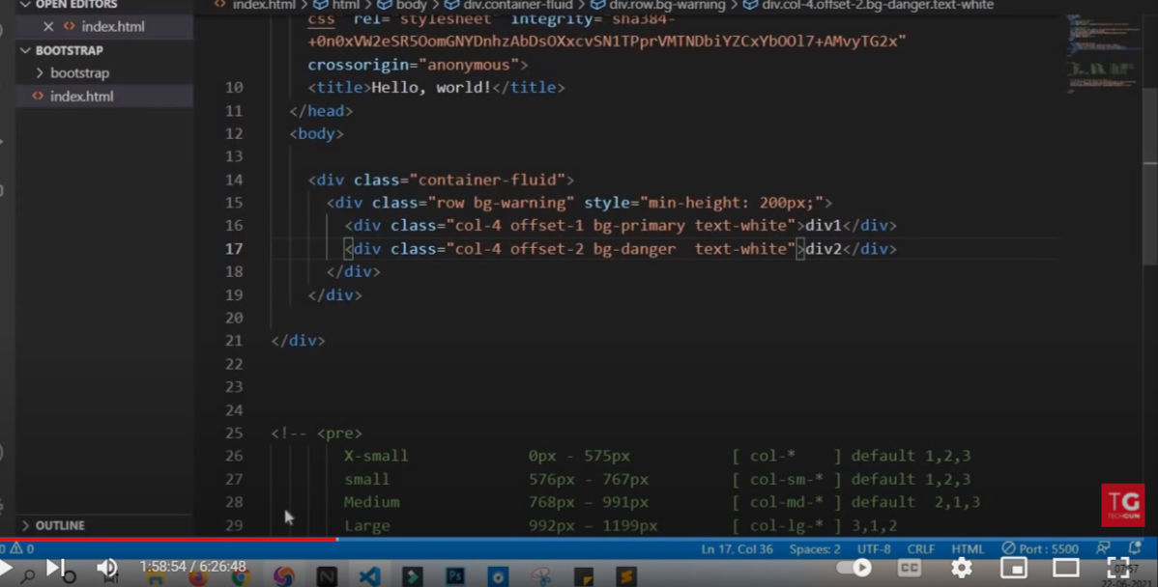

* 6. To make image responsive for all breakpoint

We can use class class=”img-fluid”

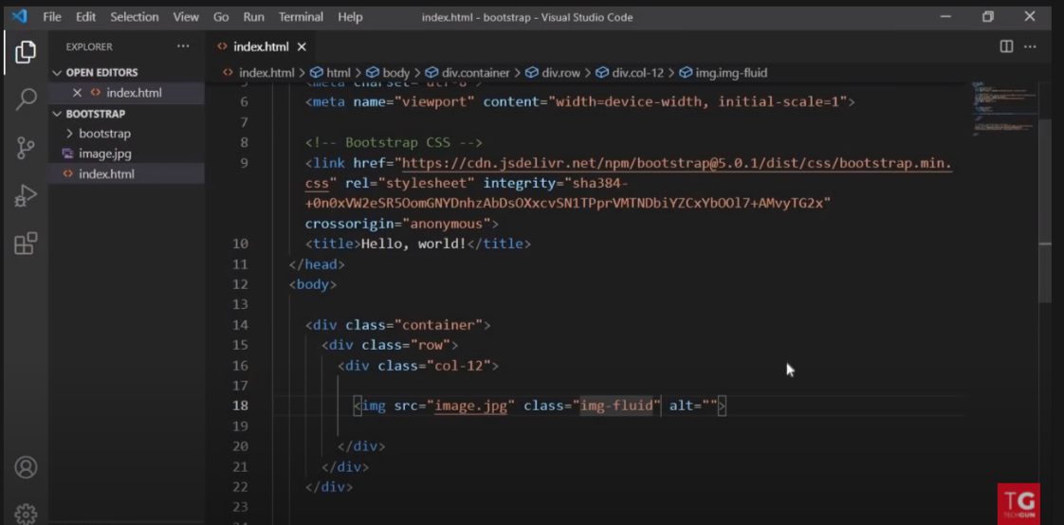

* 7. To make edge of anything round wheter it image or border

By using class class=”rounded”

* 8. Table bootstrap : copy paste from bootstrap documentation

Link : <https://getbootstrap.com/docs/5.1/content/tables/>

9. FORM

<https://getbootstrap.com/docs/5.1/forms/overview/>

10. component

* 1. Accordion link - <https://getbootstrap.com/docs/5.1/components/accordion/>

class="accordion-collapse collapse show" // remove show to remove auto open

b . alert link :